DWDM MUX DEMUX 1U RACK 4Slot
Description
DWDM which is usually used for long-haul transmission where wavelengths are packed tightly together over the C-band, up to 48 wavelengths in 100GHz grid(0.8nm) and 96 wavelengths in 50GHz grid(0.4nm). It's protocol and rate transparent supporting such applications as 1G/10G Ethernet, SDH/SONET and 8/4/2/1G Fiber Channel across the same fiber link.

That provides a reliable, flexible and efficient high bandwidth carrying solution for the operators, Broadcast and TV, IDC, finance, government, cloud, massive data and other industries.

Features:
--Low Insertion Loss
--High Isolation
--Compact module for simple installation
--Good channel-to-channel uniformity
--Wide Operating Wavelength: ITU C-BAND
--Wide Operating Temperature: -20 to 75°C
--Customized manufacturing, aluminum material for light weight

Function Structure:

Product specification

Parameters
Channels |  | 8CH | 8CH+1310nm
Center Wavelength (nm) |  | ITU, C-band
Passband (nm) |  | ITU±0.13
Operating Wavelength (nm) |  | DWDM C-band
Channel Space (nm) |  | 0.8nm 100GHZ
Fiber Type |  | SMF-28e or customer specified
IL (dB) |  | 2.4 | 2.8
Isolation (dB) | Adjacent Channel | ≥30
Isolation (dB) | Non-Adjacent Channel | ≥ 40
PDL (dB) |  | ≤ 0.2
PMD (ps) |  | ≤ 0.2
RL (dB) |  | ≥ 45
Directivity (dB) |  | ≥ 50
Maximum Optical Power (mw) |  | ≤ 500
Operating Temperature ()℃ |  | -20～75
Storage Temperature ()℃ |  | -40～85
LGX Box | Weight | 0.5kg
LGX Box | Dimensions | 190*150*20mm
1U Rack Package | Weight | 1.5kg
1U Rack Package | Dimensions | 440*160*44MM

NO. | PART NAME | PART NO. | Product Des.
 | Dual fiber
1 | DWDM Devices | FZ-DWD8-LGX01-C2128 | DWDM MUX DEMUX 8ch (C21-C28nm) with Express Port Dual fiber LC/UPC LGX Box
2 | DWDM Devices | FZ-DWD8-LGXB01-C3138 | DWDM MUX DEMUX 8ch (C31-C38nm) with Express Port Dual fiber LC/UPC LGX Box
3 | DWDM Devices | FZ-DWD8-LGXB01-C2128-31 | DWDM MUX DEMUX 8ch (C21-C28nm) with 1310nm and Express Port Dual fiber LC/UPC LGX Box
4 | DWDM Devices | FZ-DWD8-LGXB01-C3138-31 | DWDM MUX DEMUX 8ch (C31-C38nm) with 1310nm and Express Port Dual fiber LC/UPC LGX Box
 | Single fiber(used in pair)
1 | DWDM Devices A | FZ-DW28-LGXB01-C2128 | DWDM MUX/DEMUX 4ch 8wavelengths (TX C21-C24/ RX C25-C28) with Express port single fiber LC/UPC LGX Box
1 | DWDM Devices B | FZ-DD8-LGXB01-C2128 | DWDM MUX/DEMUX 4ch 8wavelengths (TX C25-C28/ RX C21-C24) with Express port single fiber LC/UPC LGX Box
2 | DWDM Devices A | FZ-DW16-LGXB01-C2136 | DWDM MUX/DEMUX 8ch 16wavelengths (TX C21-C28/ RX C29-C36) with Express port single fiber LC/UPC LGX Box
2 | DWDM Devices B | FZ-DD16-LGXB01-C2136 | DWDM MUX/DEMUX 8ch 16wavelengths (TX C29-C36/ RX C21-C28) with Express port single fiber LC/UPC LGX Box
 | Others
1 | 1U Rack | FZ1U-4LGX01 | 4 Slots 1U Rack for LGX Box 440*160*44MM
Product Order Information:

Product Panel

Dual fiber

FZ-DWD8-LGXB01-C2128
DWDM MUX DEMUX 8ch (C21-C28nm) with Express Port Dual fiber LC/UPC LGX Box

FZ-DWD8-LGXB01-C3138
DWDM MUX DEMUX 8ch (C31-C38nm) with Express Port Dual fiber LC/UPC LGX Box

FZ-DWD8-LGXB01-C2128-31
DWDM MUX DEMUX 8ch (C21-C28nm) with 1310nm and Express Port Dual fiber LC/UPC LGX Box
FZ-DWD8-LGXB01-C3138-31
DWDM MUX DEMUX 8ch (C31-C38nm) with 1310nm and Express Port Dual fiber LC/UPC LGX Box

Single fiber

FZ-DW8-LGXB01-C2128
DWDM MUX/DEMUX 4ch 8wavelengths (TX C21-C24/ RX C25-C28) with Express port single fiber LC/UPC LGX Box
DWDM Devices A

FZ-DD8-LGXB01-C2128
DWDM MUX/DEMUX 4ch 8wavelengths (TX C25-C28/ RX C21-C24) with Express port single fiber LC/UPC LGX Box
DWDM Devices B

FZ-DM16-LGXB01-C2136
DWDM MUX/DEMUX 8ch 16wavelengths (TX C21-C28/ RX C29-C36) with Express port single fiber LC/UPC 1U LGX Box
DWDM Devices A

FZ-DD16-LGXB01-C2136
DWDM MUX/DEMUX 8ch 16wavelengths (TX C29-C36/ RX C21-C28) with Express port single fiber LC/UPC LGX Box

DWDM Devices B

Product Linking
Dual Product Application Single fiber Application
B Remote
Data Center

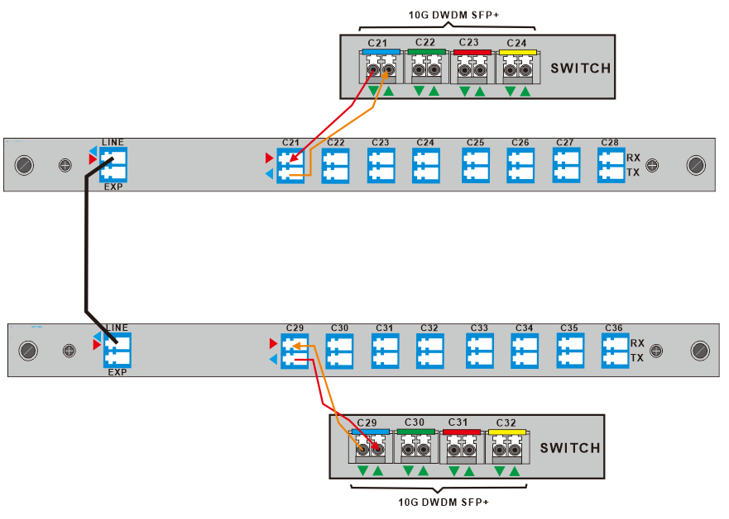
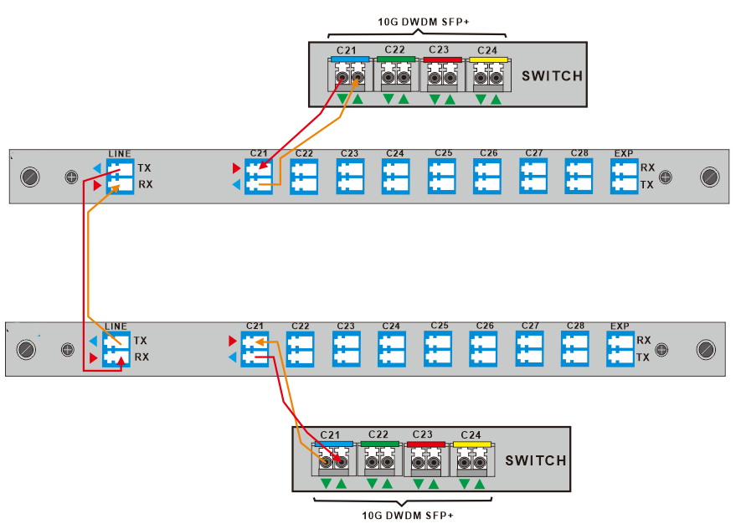
A Local Data Center
A Local
Data Center

One Core Fiber
Two Core Fiber

B Remote
Data Center
B Remote
Data Center

A Local
Data Center
λC Wavelength Guide

100GHZ DWDM ITU Waves
ITU Channel  Product Code | Frequency(THz) | Wavelength | ITU Channel  Product Code | Frequency(THz) | Wavelength
17 | 191.7 | 1563.86 | 40 | 194.0 | 1545.32
18 | 191.8 | 1563.04 | 41 | 194.1 | 1544.52
19 | 191.9 | 1562.23 | 42 | 194.2 | 1543.73
20 | 192.0 | 1561.41 | 43 | 194.3 | 1542.93
21 | 192.1 | 1560.60 | 44 | 194.4 | 1542.14
22 | 192.2 | 1559.79 | 45 | 194.5 | 1541.34
23 | 192.3 | 1558.98 | 46 | 194.6 | 1540.55
24 | 192.4 | 1558.17 | 47 | 194.7 | 1539.76
25 | 192.5 | 1557.36 | 48 | 194.8 | 1538.97
26 | 192.6 | 1556.55 | 49 | 194.9 | 1538.19
27 | 192.7 | 1555.74 | 50 | 195.0 | 1537.40
28 | 192.8 | 1554.94 | 51 | 195.1 | 1536.61
29 | 192.9 | 1554.13 | 52 | 195.2 | 1535.82
30 | 193.0 | 1553.32 | 53 | 195.3 | 1535.04
31 | 193.1 | 1552.52 | 54 | 195.4 | 1534.25
32 | 193.2 | 1551.72 | 55 | 195.5 | 1533.46
33 | 193.3 | 1550.92 | 56 | 195.6 | 1532.68
34 | 193.4 | 1550.11 | 57 | 195.7 | 1531.89
35 | 193.5 | 1549.32 | 58 | 195.8 | 1531.12
36 | 193.6 | 1548.51 | 59 | 195.9 | 1530.33
37 | 193.7 | 1547.71 | 60 | 196.0 | 1529.55
38 | 193.8 | 1546.92 | 61 | 196.1 | 1528.77
39 | 193.9 | 1546.12 | - | - | -

